1. **List all available shells on your Linux distribution.**

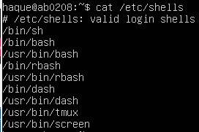

1. **Find general guidelines using man command for user password (Hint: passwd).**  
   Command: “*man passwd”*

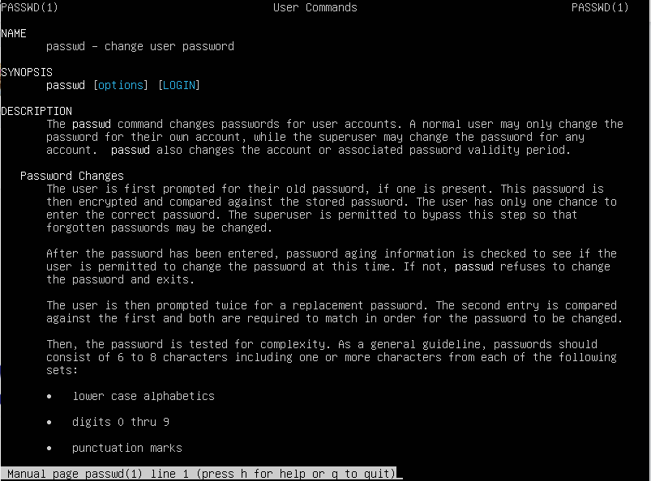

1. **How can you change your user from regular to root user and back to regular?**

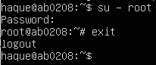

1. **Find out what is the description of the following Linux commands:**
   * echo  
     Command: *“man echo”*

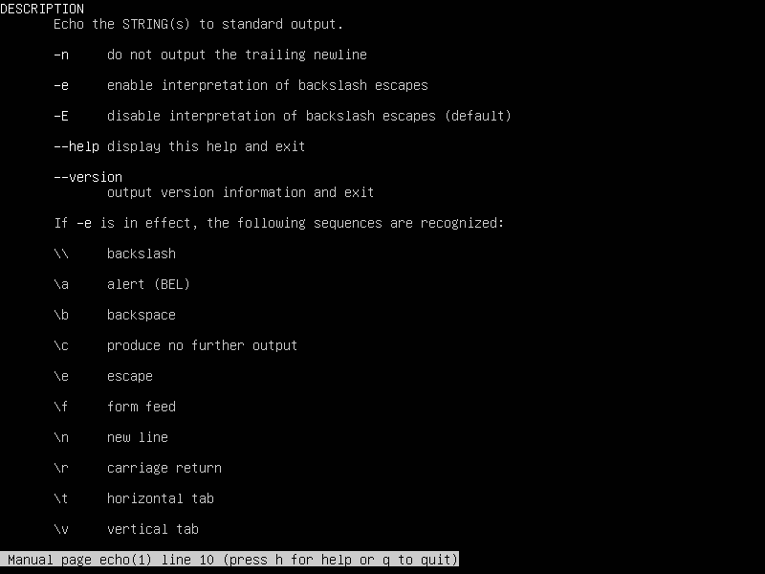

* free  
  Command: *“man free”*

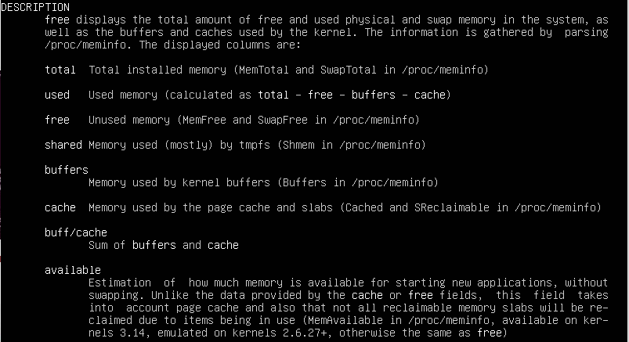

* + history  
    Command: *“man history*”



* + w  
    Command: “*man w*”

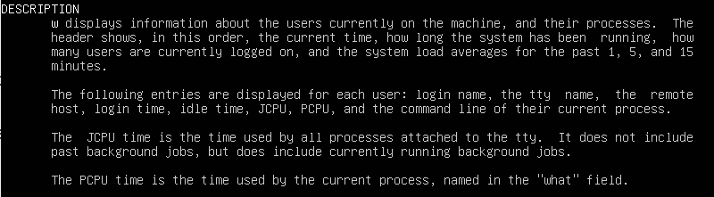

1. **Give an example of all of the above commands and command outputs.**

* echo  
  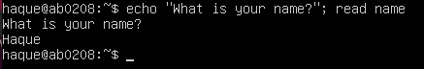
* free: f  
  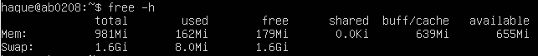
* history: history  
  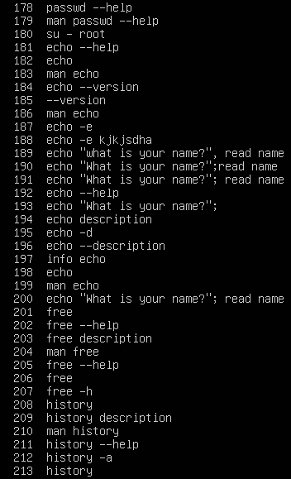
* w: w  
  